<http://blog.sqlauthority.com/2010/11/03/sql-server-fix-error-ms-jet-oledb-4-0-cannot-be-used-for-distributed-queries-because-the-provider-is-used-to-run-in-apartment-mode/>

1. After many struggles with this issue, I found the following solution:

1. On 64-bit servers and boxes, you need to first UNINSTALL all 32-bit Microsoft Office applications and instances (Access 2007 install, Office 10 32-bit, etc.). If you dont, you cannot install the new 64-bit Microsoft Access Database Engine 2010 Redistributable components. Yes, its a headache but the only way I found to install the new replacements for the JET engine components that need to run on 64-bit machines.

2. Download and install the new component from Microsoft:  
<http://www.microsoft.com/downloads/en/details.aspx?FamilyID=c06b8369-60dd-4b64-a44b-84b371ede16d&displaylang=en>  
* This will install the access and other engines you need to set up linked servers, OPENROWSET excel files, etc.

3. Open up SQL Server and run the following:

sp_configure ‘show advanced options’, 1;  
GO  
RECONFIGURE;  
GO  
sp_configure ‘Ad Hoc Distributed Queries’, 1;  
GO  
RECONFIGURE;  
GO

EXEC master.dbo.sp_MSset_oledb_prop N’Microsoft.ACE.OLEDB.12.0′, N’AllowInProcess’, 1  
GO  
EXEC master.dbo.sp_MSset_oledb_prop N’Microsoft.ACE.OLEDB.12.0′, N’DynamicParameters’, 1  
GO

* This sets the parameters needed to access and run queries related to the components. Address ‘null

4. Now, if you are running OPENROWSET calls you need to abandon calls ,made using the old JET parameters and use the new calls as follows:

(*Example, importing an EXCEL file directly into SQL):

DONT DO THIS….

SELECT * FROM OPENROWSET(‘Microsoft.Jet.OLEDB.4.0′,’Excel 8.0;HDR=YES;Database=c:\PATH_TO_YOUR_EXEXCEL_FILE.xls’,'select * from [sheet1$]‘)

USE THIS INSTEAD…

SELECT * FROM OPENROWSET(‘Microsoft.ACE.OLEDB.12.0′, ‘Excel 12.0;Database=c:\PATH_TO_YOUR_EXEXCEL_FILE.xls’,'select * from [sheet1$]‘)

*At this point resolved two SQL issues and ran perfectly

5. Now for the fun part…..find all your Office Disks and reinstall Office and/or applications needed back onto the machine. You can install the 64- bit version of Office 10 by going onto the disk and going into the 64-bit folder and running it but beware as in some cases some third party apps dont interface yet with that version of Office.

Hope that help!

Para acesso de usuários NÃO ADMIN, é necessário inserir a chave de registro abaixo no servidor:

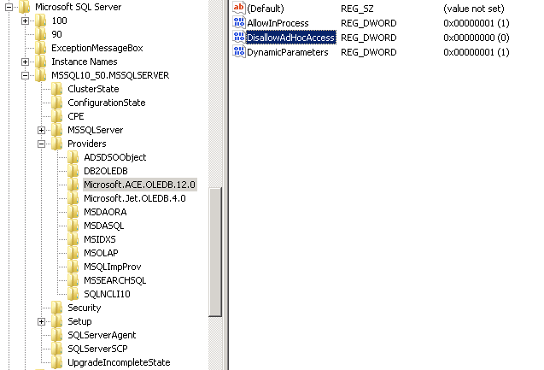

Reiniciar o Servidor.